Module Title: Programming Strand

Module Code: COMP10082

Name: Dayeeta Das

NTU ID: N0830182

Year: 1st Year

Project Title: Maths Test for Kids

Name: Dayeeta Das

NTU ID: N0830182

Aims of the Program:

Maths Tester for kids

This program aims to create a maths test with three different levels:

* Easy
* Medium
* Hard

Each contains 20 questions with a time limit of 2 minutes. Candidates can input their name and choose a level of their choice.

A right answer fetches 2 points and a wrong answer cuts down two points.

The total score and all the questions along with their answers are displayed at the end of the exam.

Name: Dayeeta Das

NTU ID: N0830182

Requirements of the program:

Maths Tester for kids

* Three lists (e [], m [] and h []) that stores the numbers used for making the equations for the three different levels, viz: easy, medium and hard.
* A list (operators []) for storing the various operators like +, -, \*, /.
* A dictionary (levels {}) that stores the level name as the key and the list that contains the numbers in its range as the value. Eg: “easy” is the key and “e” is the value where e= [2,4,6,8]
* A function (instructions ()) for displaying the rules of the test.
* File handling for writing the name and level for which the candidate is taking the test along with all the questions and answers and reading them at the end of the test, storing the names of the candidates who have got the higher grades.
* The random function from the random module for randomly choosing the numbers and the operators for creating the equations.
* The time and ctime functions from the time module for checking the start time and giving a limit to the exam and for showing the current time when the exam starts.
* Iterations for checking if the name of the level given as input is present in the dictionary or not, for displaying messages and scores for the right and wrong answers.
* Iterations for displaying messages and total score once the time for the exam is over and displaying if the candidate has completed the exam on time, before time or haven’t been able to complete.
* Variables of different data types for storing the necessary values as per the requirement of the program.

Name: Dayeeta Das

NTU ID: N0830182

Design of the program:

Maths Tester for kids

• The time and random module are imported.

• The necessary variables are initialized.

• The numbers to be used in the three different levels are stored in three different lists. The operators are stored in a list.

• A dictionary is created for storing the names of the level along with the list that contains the numbers for that level.

• The instructions for the test are displayed by calling the function.

• A file, “name.txt” and a file “high scores.txt” is opened.

• The name and level are taken as input from the candidate. A check is performed to confirm if the name is valid or not, if valid it is written in the text file

• The current time is displayed, and the start time is initialized.

• The iteration starts here.

• A check is performed to confirm if the name of the level is present in the dictionary or not.

• If the name of the level is not present then a message is displayed, and the program stops(breaks).

• If the name of the level is present then the timer is set to 2 minutes, 20 questions are asked which are formed by numbers and operators that are randomly generated.

• The answer is taken as input after displaying each question.

• The questions along with the right answers are written in the text file and then the file is closed.

• A message is displayed after each answer as to whether it is correct or not.

• A check is performed, and messages are displayed for the candidate if he/she has completed the exam on time, before time or has been unable to complete it.

• The total score is displayed. The name of the candidate is stored in the high scores file if he/she scores above half of the total marks. Then it is closed.

• “name.txt” is opened and all the questions along with the answers are displayed at the end of the exam for Clarity

•The text file is closed again at the end of the program.

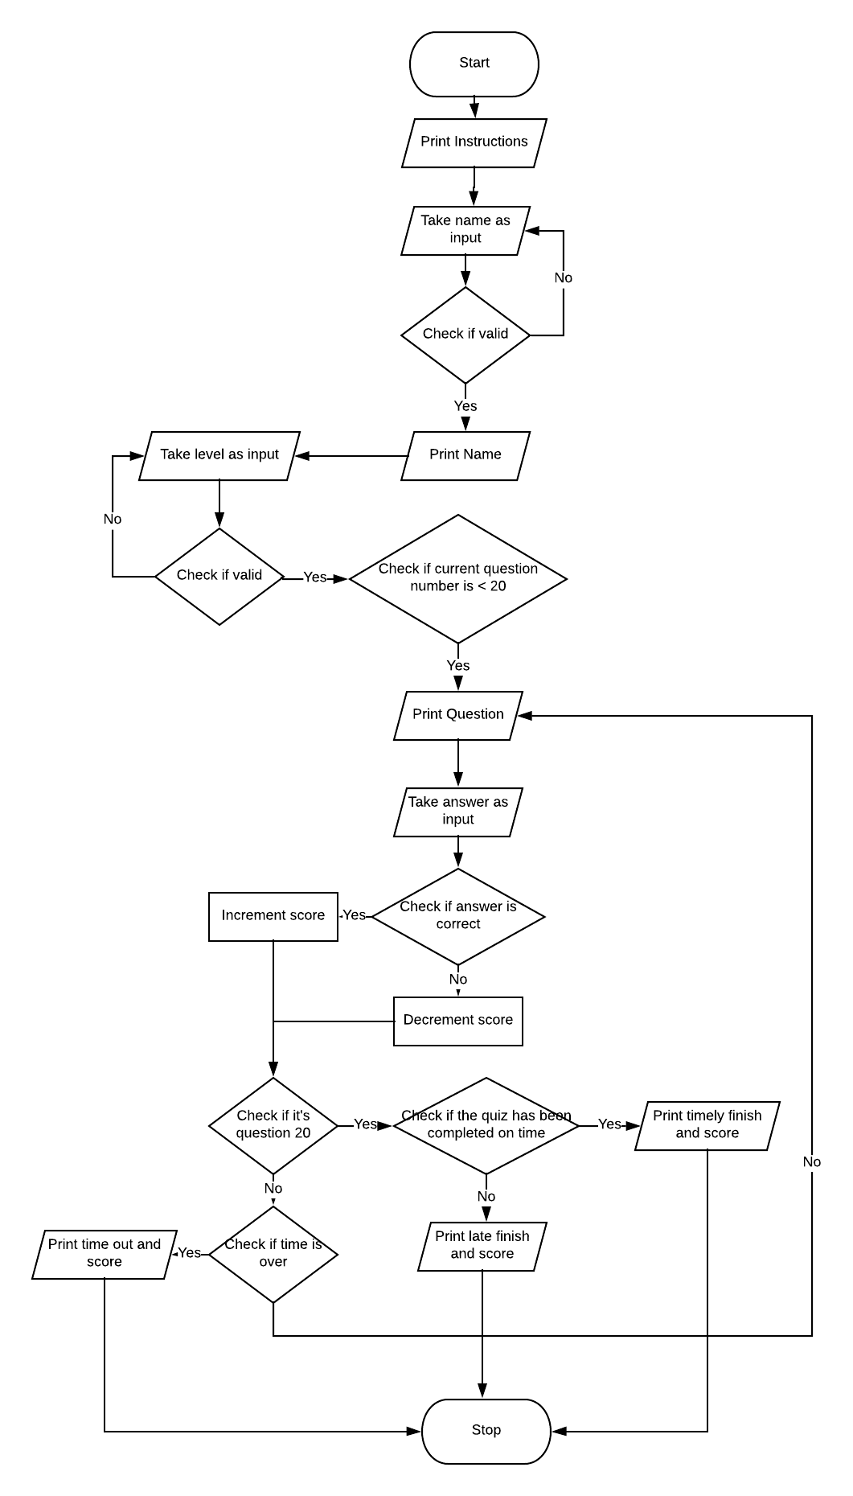

Name: Dayeeta Da

NTU ID: N0830182

Testing the program:

Maths Tester for kids

* When the input is right

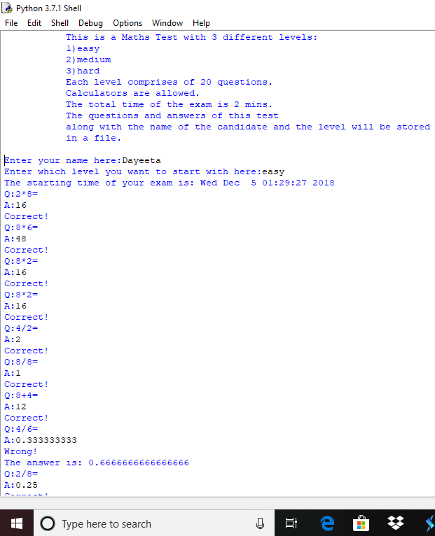

The questions are shown. Correct or Wrong is displayed based on

whether the answer is right or not.

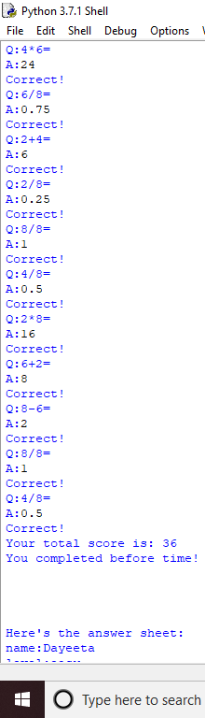

The total score is shown. A message is displayed based on the timing in which the candidate completes the exam.

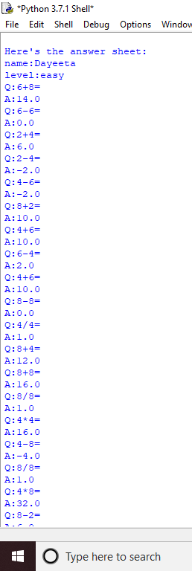

Answer sheet is displayed at the end of the exam.

* When the input is wrong

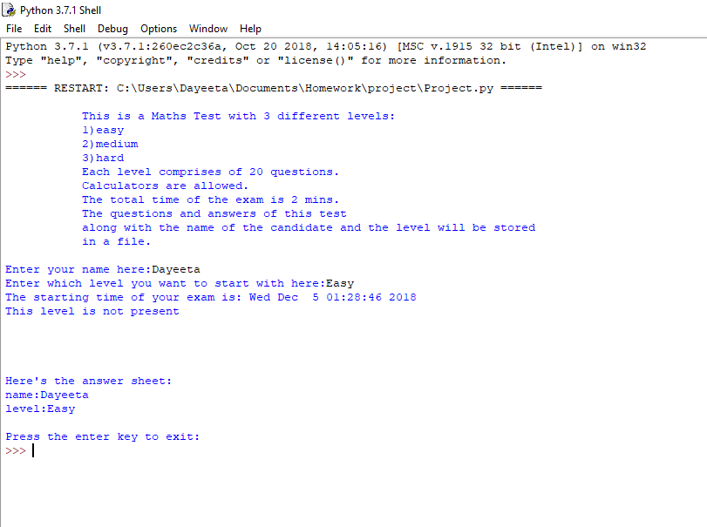

When the wrong level is mentioned.

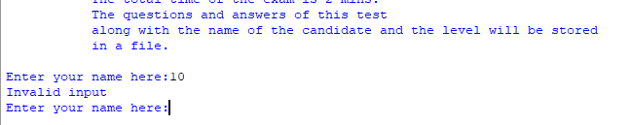

When the wrong name is mentioned.

Name: Dayeeta Das

NTU ID: N0830182

Critique on program:

Maths Tester for kids

* The pattern of the exam with the timing seems just.
* Certain questions are repeated. This can also occur in a real-life exam where certain questions can come on repeat. Nevertheless, this aspect can be a matter of debate.
* The name and level get written in the text file even when the level name is not right, and the answer sheet gets displayed as a blank page.
* Zeroes have been omitted from the lists containing the numbers because it often showed the “Division by Zero” error.
* Overall, the program generates a maths test very similar to the practical world.